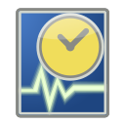
Tg
Timegrapher

User Manual

Copyright
This work is licensed under the Creative Commons Attribution 4.0 International License. To view a copy of this license, visit http://creativecommons.org/licenses/by/4.0/ or send a letter to Creative Commons, PO Box 1866, Mountain View, CA 94042, USA.

Authors
David Schonert

Publication Date and Software Version
May 2023, Tg version 0.5.0

Table of Contents
Copyright 2
Authors 2
Publication Date and Software Version 2
Introduction 4
Requirements 4
Installation 5
Windows 7 and above 5
Other Operating Systems 6
Main Window 7
Menu 8
Calibration 8
Watch Timing 9
Starting 9
Signal Quality 9
How to read the results 9
Snapshots 10
Troubleshooting 11
Signal Quality not staying green or is poor quality 11
Too much noise on Scope Graph 11
No signal detected 11
Calibration failed 11

Introduction
Tg is a free and open-source timegraphing program for the timing of mechanical watches. Tg uses an external microphone combined with software filtering to listen for the ticking made by the escapement of a mechanical watch. The advanced filtering used allows the use of non-specialized microphones to pick up the noises from the watch. This provides a very cost-effective way for users without watch timing equipment to time their watches.
Tg automatically detects the rate of the watch and displays the deviation in seconds per day, the beat error in ms, and the amplitude in degrees. Along with the timing data, the software also displays a rate chart and scope graphs of the watch timing. This user manual explains how to operate Tg and is written for users that already have a basic understanding of the concept of watch timing.
Tg is a cross-platform open-source project, below are links to the download page and the GitHub project.
Download page https://tg.ciovil.li/
GitHub Project https://github.com/vacaboja/tg

Requirements
Computer
1GB Ram
50MB Free Space
External microphone
TIP
Tg is designed to isolate the noise of the watch and does not require specialized microphones or vibration pickups. Small microphones that can touch or be very close to the watch work best. A quiet space is recommended as fans and other continuous noise sources can cause interference with the timing of the watch.

Installation

Windows 7 and above
- Download tg-timer_0.5.0.msi from the download page https://tg.ciovil.li/
- Once the download is complete, open tg-timer_0.5.0.msi
- The installation starts with the Welcome to the Tg Setup Wizard page  - Click Next | 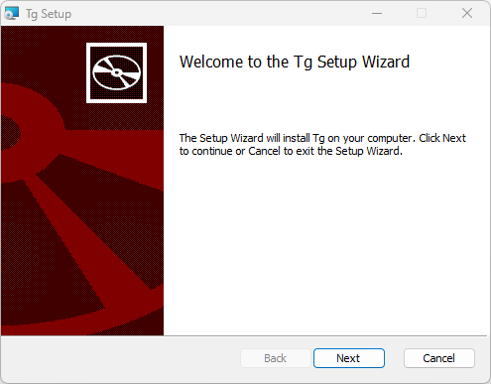
- The End-User License Agreement page explains the software license  - Read the agreement  - Check the box I accept the terms in the License Agreement  - Then click Next | 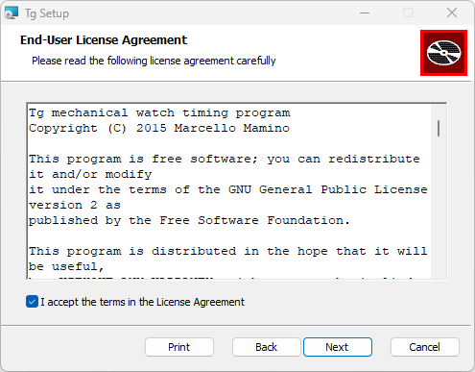
- The Destination Folder page allows the user to set the install location  - Leave the location as the default or click Change… to bring up a dialog for selecting a new location  - Then click Next | 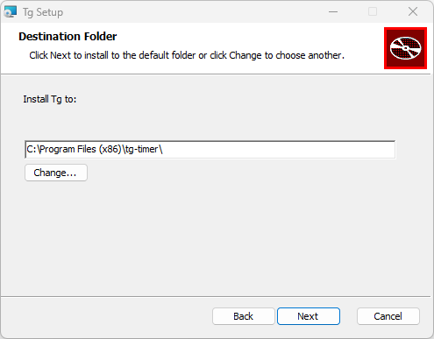
- The Ready to install Tg page informs the user the installation will start  - When ready click Install | 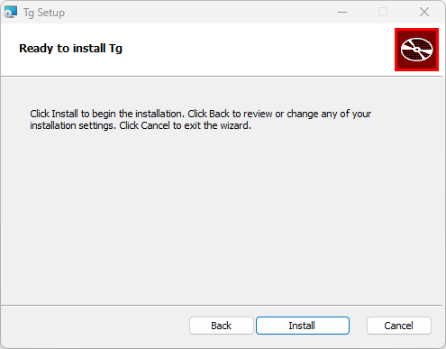
- Wait for the installation progress to complete
- The Completed the Tg Setup Wizard page informs the user the installation is done  - Click Finish | 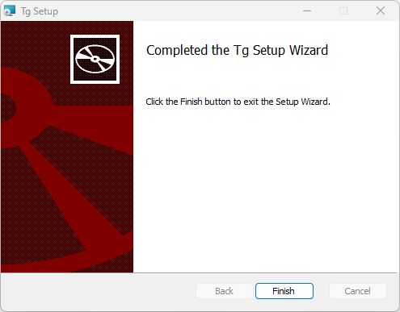

Other Operating Systems
Tg is cross-platform compatible and there are installers for older versions of Windows, Mac OS X, Linux Debian 64bit and 32bit. Tg can also be compiled from the source code, see the download page for installers and source code. https://tg.ciovil.li/

Main Window
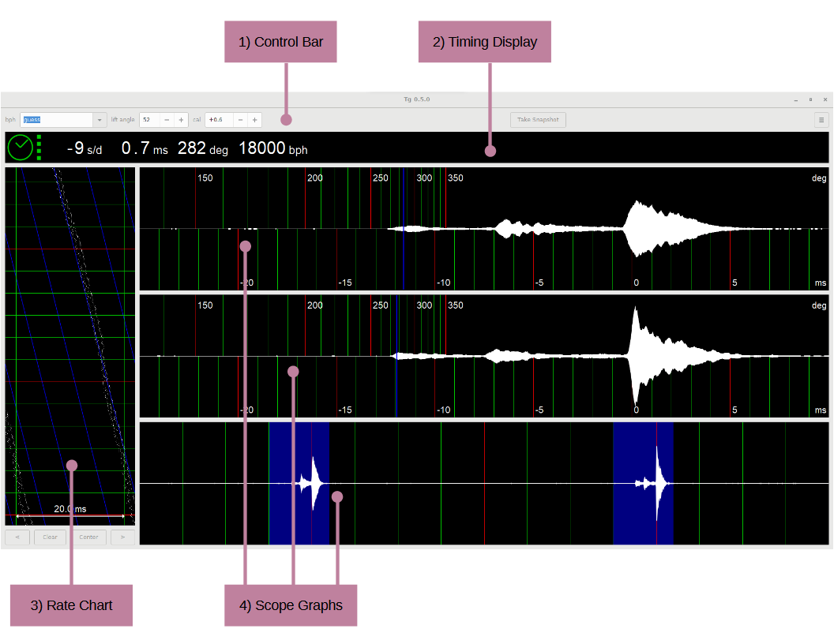
- Control Bar – Allows the parameters for the timing to be set: rate of the movement in bph (Beats Per Hour), lift angle of movement in degrees, and cal (calibration offset). The control bar also allows the user to Take Snapshot of the current timing. On the far right is the Menu with other options.
- Timing Display – This shows the current timing data of the watch. From left to right: Signal Quality, Rate Deviation in s/d, Beat Error in ms, Amplitude in degrees, and Rate in bph.
- Rate Chart – This chart displays the rate deviation and beat error over time. There are controls at the bottom to adjust the horizontal position and clear the chart.
- Scope Graphs – These graphs display a complete cycle of the balance wheel containing two ticks. The top two graphs show each tick of the escapement and have a scale for the amplitude calculation. The bottom graph shows both ticks together.

Menu
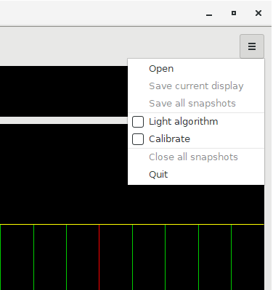
Open – Opens a dialog to open a saved snapshot.
Save current display – Opens a dialog to save the currently displayed snapshot.
Save all snapshots – Opens a dialog to save all open snapshots.
Light algorithm – When toggled, Tg will run a less processing-intensive algorithm for filtering out noise. Useful if Tg is being run on a slower computer.
Calibrate – Enables calibration mode. See the calibration selection for more details.
Close all snapshots – Closes all open snapshots.
Quit – Closes Tg.

Calibration
Before first using Tg, calibration needs to be performed. The calibration takes about 15 minutes and uses a quartz watch to calibrate the sound card of the computer. The sound card very precisely measures frequency but each card will have an offset that needs to be corrected to get accurate timing from a watch. Any time the sound card is changed, for example switching to an external sound card, a new calibration needs to be performed. Basic quartz watches work best as they have no compensation circuits that can affect the calibration process.
To use automatic calibration:
- Place the microphone on a quartz watch.
- Click the Calibrate option in the menu.
- Wait for the beat of the watch to be detected and the calibration to start.
- Wait for the calibration to complete. This step will take about 15 minutes and has a progress indicator.
- Once complete the new calibration value will be updated in the cal field.
- Uncheck the Calibrate option in the menu.
To use manual calibration:
- Press the + or – in the cal field until the desired calibration value is reached.

Watch Timing
TIP
Before starting the software, connect the microphone to the computer and make sure that any noise canceling or filtering is turned off on the computer.

Starting
A mechanical watch can be timed by placing the microphone on or near the watch.
- Start by selecting the bph of the watch movement from the drop-down menu. If you select guess, Tg will attempt to figure out what bph to use for the watch.
- Set the Lift Angle for the watch. If the lift angle is unknown, use 52°; this is the most common angle for wristwatches.
- Wait for the Signal Quality to turn green and stay green.
- Depending on the quality of the signal, it can take some time before the timing stabilizes and an accurate result is shown.

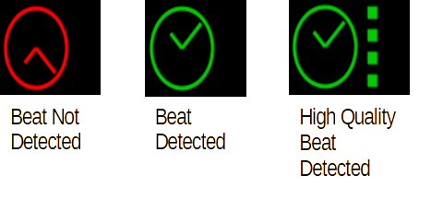
Signal Quality
The Signal Quality displays the current status of the detected watch beat. When there is no beat detected the icon is red. Once the beat is detected the icon will turn green. On the right side of the icon, a column of squares will appear to indicate the quality of the detection. No squares is the lowest quality and four squares is the highest. Lower-quality signals can cause the timing information to be inaccurate or not displayed.

How to read the results
The timing values are shown in the Timing Display. This display has the rate deviation in s/d, the beat error in ms, the balance amplitude in degrees, and the rate in beats per hour.
The Rate Chart shows the rate deviation and beat error in a chart over time. The chart is updated every beat and runs from top to bottom. Each beat will have two dots on the chart. The horizontal distance between the dots indicates the beat error, the larger the error the farther apart the dots. If there is a beat error of 0.0ms then the beat will appear as only one dot. The rate deviation is displayed as a sloping line of dots with a vertical line representing no deviation. The rate chart is useful for diagnosing issues with the watch that happen over time.
The Scope Graph shows the noise of each beat in real-time. This graph is made up of three windows: the top two show the individual ticks and the bottom shows both ticks together. The individual displays have a scale showing the amplitude calculation in both degrees and milliseconds. Seeing the noise as the impulse jewel passes through the pallet fork gives valuable information when diagnosing issues in the escapement.
INFO
The beat noise of the Swiss lever escapement consists of three different impulses. The first noise is from the impulse-pin striking the fork of the pallet. The second noise is created by a tooth of the escape-wheel meeting the pallet stone and pallet fork touching the impulse-pin. The third noise is the loudest and is caused by a tooth of the escape-wheel hitting the locking-plane of the pallet stone and the pallet fork hitting the banking-pin.

Snapshots
The snapshot feature allows the user to capture the timing data at the moment the Take Snapshot button is pressed. The new snapshot is displayed in a new tab that can be labeled. Multiple snapshots can be captured and viewed. This allows the user to quickly compare the watch timing in different positions for example. Snapshots can be saved for later viewing in Tg.
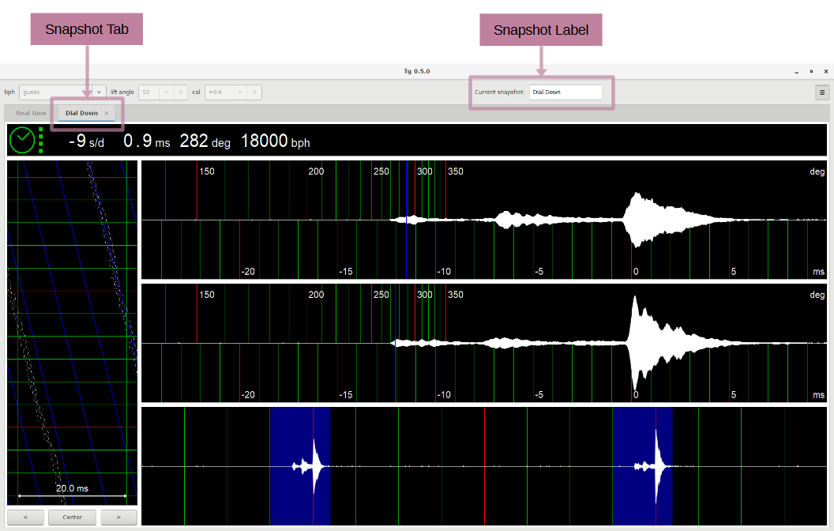

Troubleshooting

Signal Quality not staying green or is poor quality
If the Signal Quality display is switching between green and red or the quality indication is staying at two or less squares, this indicates that there is an issue with either too much noise in the environment or too weak of a beat noise from the watch. First, check the Scope Graph to make sure that you can see some sort of beat being displayed.
If the watch beat can be seen, follow the instructions for Too much noise on Scope Graph. Otherwise, if no watch beat can be seen, follow the instructions for No signal detected.

Too much noise on Scope Graph
If the graph looks noisy the software may not be detecting the watch beat correctly. Try turning off any sources of noise or moving to a new location. The computer fans can be a source of noise and moving the computer away from the microphone can help. Also check the placement of the microphone to make sure that it is as close as possible to the watch, sometimes switching placement sides can help.

No signal detected
If no watch beat can be seen on the graph but other noises are present, this indicates that there is an issue with the microphone picking up the watch beat.
Check to make sure that the correct microphone is selected on the computer's operating system (Tg uses the microphone the operating system marks as active).
Next check the placement of the microphone to make sure that it is as close as possible to the watch, sometimes switching placement sides can help.
Next, check if the sound card or operating system has any noise canceling turned on. Noise-canceling will remove the watch beat noise along with the background noise being picked up by the microphone.

Calibration failed
If the calibration failed it is likely caused by issues with the watch signal from the microphone.
If the watch beat can be seen, follow the instructions for Too much noise on Scope Graph. Otherwise, if no watch beat can be seen, follow the instructions for No signal detected.

